

**Faculty of Engineering & Technology – Electrical & Computer Engineering Department**

**First Semester 2022 – 2023**

**Circuits and electronics lab**

**ENEE2103**

**PRELAB EXP.4**

**Name: Amal Ziad**

**ID: 1192141**

**Section: 2**

**Instructor: Dr. Nasser Ismael**

**TA: Eng. Yazan Yousef**

**Date: 11th Nov 2022**

Part1:اجوبة و عناوين

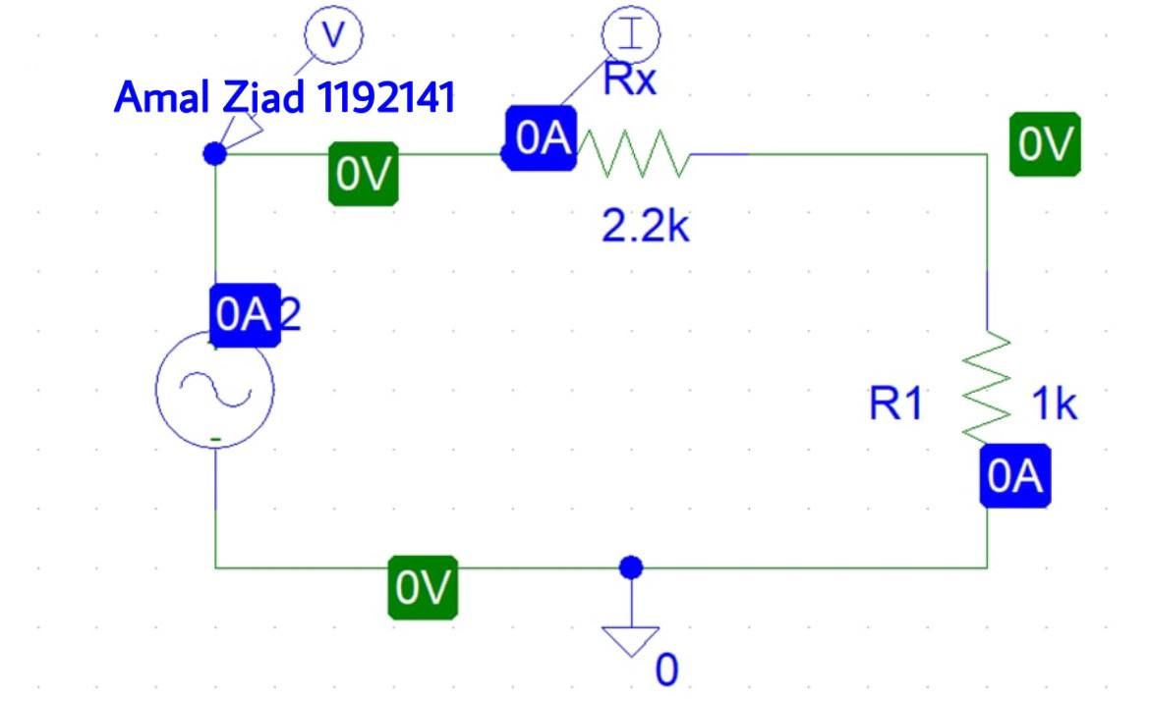

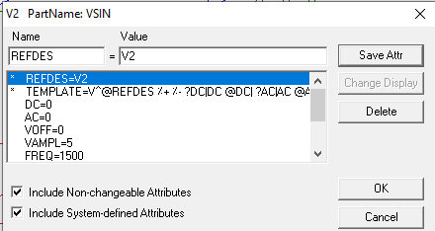



R=4.9992/1.5623=



R=4.9998/1.5624=



R=4.9967/1.5615=

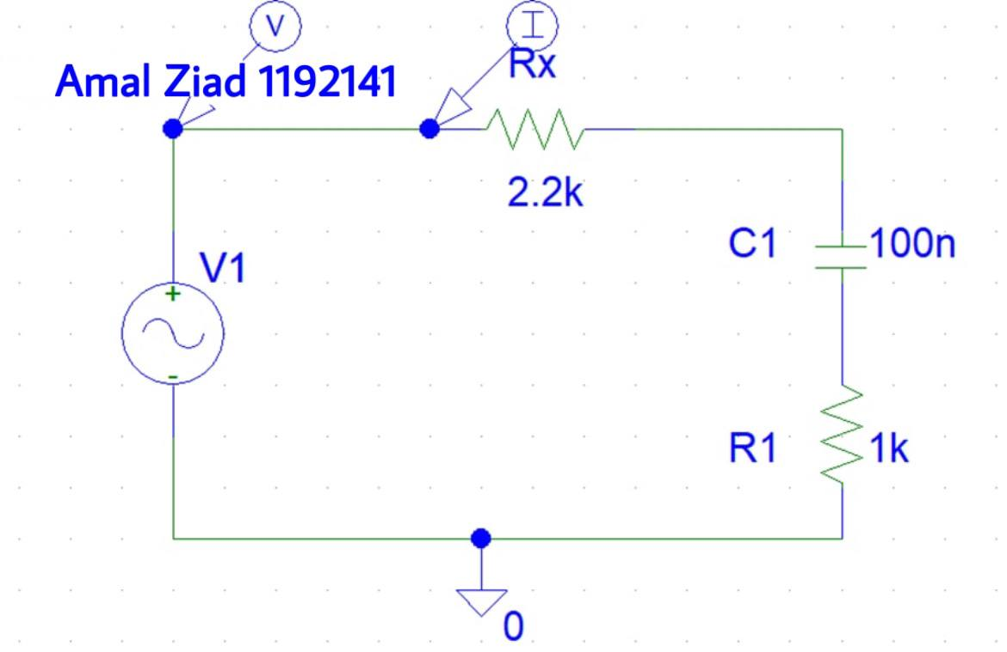







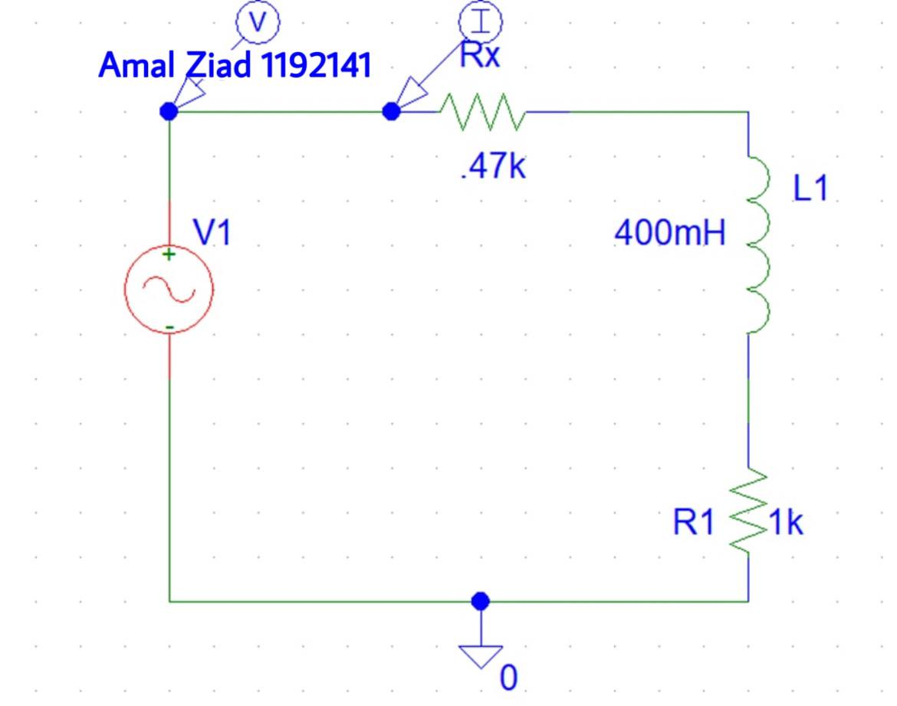







Part 2 : تكملة

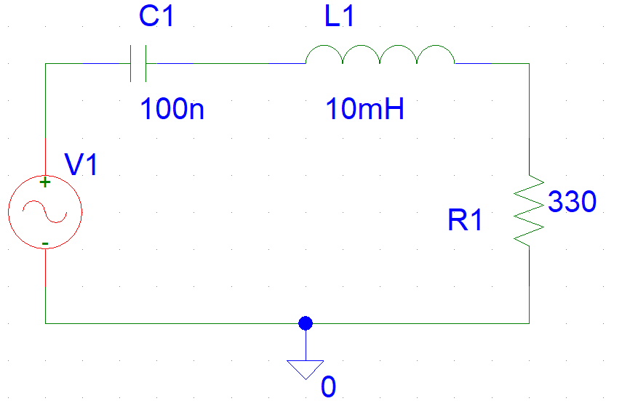

Part 3: أجوبة و عناوين

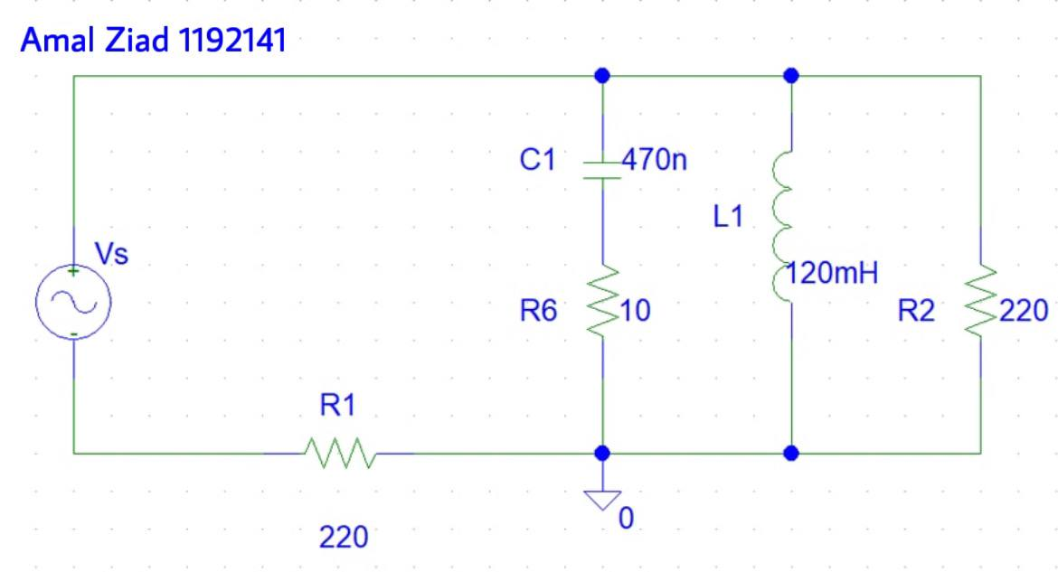

|  |  |  |  |  |  |  |
| --- | --- | --- | --- | --- | --- | --- |
| Vs | Is | V(R1) | Ovs-Ois | Vc | Ic | Ovc-Oic |
|  |  |  |  |  |  |  |







|  |  |  |  |  |  |
| --- | --- | --- | --- | --- | --- |
| Vl | Il | Ovl-Oil | Vr6 | Ir6 | Ovr6-Ir6 |
|  |  |  |  |  |  |



